Exp 2 : Implementing TDMA Slot Allocation in GSM.

Objective 1 :

Code :

clc;
clear;
close all;

FrameTime = 4.615;

Slots = 8;

SlotDuration = FrameTime / Slots;

t = 0:SlotDuration:FrameTime;

figure;

subplot(2,1,1);

stem(t, ones(size(t)), 'filled');

title('TDMA Time Slot Structure');

xlabel('Time (ms)');

ylabel('Slot Level');

grid on;

subplot(2,1,2);

plot(t, ones(size(t)), '-o', 'LineWidth', 1.5);

title('Continuous View of Slot Allocation');

xlabel('Time (ms)');

ylabel('Slot Presence');

grid on;

output:
o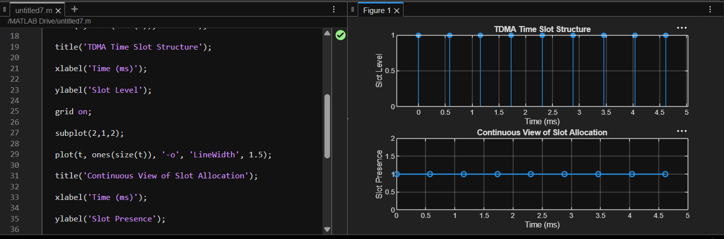

Objective 2 :

Code :

clc;
clear;
close all;

TotalSlots = 8;

AllocatedSlots = 6;

FreeSlots = TotalSlots - AllocatedSlots;

Utilization = (AllocatedSlots / TotalSlots) * 100;

disp('Frame Utilization (%)');

disp(Utilization);

figure;

subplot(2,1,1);

plot([1 2], [AllocatedSlots FreeSlots], '-o', 'LineWidth', 2);

title('GSM Frame Utilization (Allocated vs Free)');

xlabel('Slot Type Index (1 = Allocated, 2 = Free)');

ylabel('Number of Slots');

grid on;

subplot(2,1,2);

pie([AllocatedSlots FreeSlots]);

title('Slot Distribution in GSM Frame');

legend('Allocated', 'Free');

output:

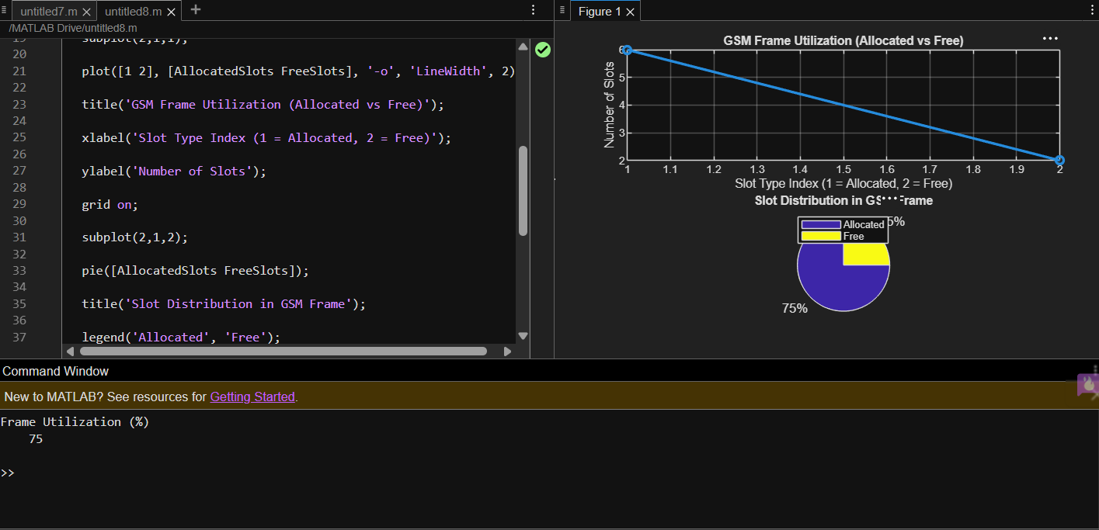

Objective 3 :

Code :

clc;
clear;
close all;

Users = 1:8;

TotalSlots = 5;

Alloc = zeros(1,8);

Alloc(1:TotalSlots) = 1;

Blocked = 1 - Alloc;

disp('User Wise Slot Allocation');

disp(table(Users', Alloc', ...
'VariableNames', {'User','Status_Allocated_1_Blocked_0'}));

figure;

subplot(2,1,1);

stem(Users, Alloc, 'filled', 'LineWidth', 2);

title('TDMA Slot Allocation per User');

xlabel('User Index');

ylabel('Slot Status (1 = Allocated, 0 = Blocked)');

ylim([-0.2 1.2]);

grid on;

subplot(2,1,2);

plot(Users, Alloc, '-o', 'LineWidth', 2);

hold on;

plot(Users, Blocked, '-s', 'LineWidth', 2);

title('TDMA Slot Utilization Analysis');

xlabel('User Index');

ylabel('Status');

legend('Allocated', 'Blocked');

grid on;

Output :

